**Case Study: The Builder Pattern in Addressing Essential Complexity**

**References:**

1. **“Design Pattern Builder** A Concept for Refinable Reusable Design Pattern Libraries”
2. “Factory Pattern vs. Builder Pattern: Choosing the Right Creational Pattern in Java”

**Introduction**

The Builder pattern is a creational design pattern that decouples the construction of complex objects from their representation, enabling flexible and maintainable code. This case study explores two real-world applications of the Builder pattern—**a pizza ordering system** and **a virtual Monopoly game using the Observer pattern**—to demonstrate how it addresses *essential complexity*, a core challenge in software engineering described by Fred Brooks in *No Silver Bullet*. Essential complexity refers to inherent difficulties in software design, such as managing intricate object relationships or dynamic configurations, which cannot be eliminated but can be mitigated through effective design patterns.

**Case 1: Pizza Ordering System**

**Background and Problem**

A pizza ordering system must handle complex configurations of pizzas, including dough types, sauces, toppings, and sizes. Traditional approaches using constructors with multiple parameters lead to **parameter explosion** and inflexibility. For example:



This approach is error-prone, hard to maintain, and lacks clarity in parameter ordering. Modifications (e.g., adding gluten-free options) require changes across all client code, violating the *Open/Closed Principle*.

**Solution: Builder Pattern**

The Builder pattern decomposes object construction into **step-by-step methods**, enabling flexible and readable configuration.

**Implementation Steps**

1. **Product Class**: Define the Pizza class with setters for optional attributes.
2. **Builder Class**: Create a PizzaBuilder with chainable methods for configuring components.
3. **Client Code**: Use the builder to construct pizzas incrementally.

**Code Example**

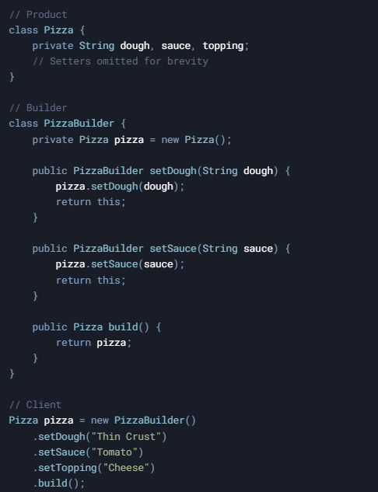

**Addressing Essential Complexity**

1. **Encapsulation of Construction Logic**  
   The Builder encapsulates the creation process, isolating complexity within the builder class. Clients focus on *what* to build, not *how*.
2. **Flexibility for Variants**  
   New pizza types (e.g., vegan or gluten-free) are added by extending the builder, avoiding changes to the core Pizza class.
3. **Readability and Safety**  
   Chainable methods clarify configuration steps, reducing errors from parameter mismatches.

**Impact on Essential Complexity**  
By decomposing construction into discrete steps and encapsulating variability, the Builder pattern manages the inherent complexity of multi-attribute object creation. It aligns with Brooks’ assertion that complexity must be *organized*, not eliminated.

**Case 2: Observer Pattern in a Virtual Monopoly Game**

**Background and Problem**

In a virtual Monopoly game, Player objects (Subjects) must notify Display objects (Observers) about balance changes. Traditional Observer implementations scatter logic across domain classes (e.g., Player and Display), leading to **tight coupling** and poor modularity. For example:

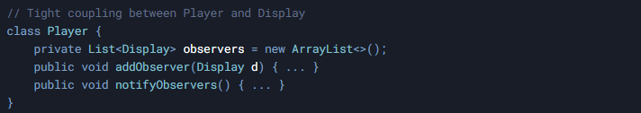

This approach makes it hard to reuse the Observer pattern in other contexts or modify design decisions (e.g., switching from a push to pull model).

**Solution: Meta-Level Builder Pattern with AOP**

A meta-level Builder pattern, combined with Aspect-Oriented Programming (AOP), modularizes the Observer pattern’s implementation, enabling dynamic configuration and reuse.

**Implementation Steps**

1. **Pattern Definition**: Abstract roles (Subject, Observer) and collaborations.
2. **Design Decisions**: Separate variable aspects (e.g., data structures, notification models).
3. **Dynamic Weaving**: Use AOP to inject behavior into domain classes.

**Code Example**

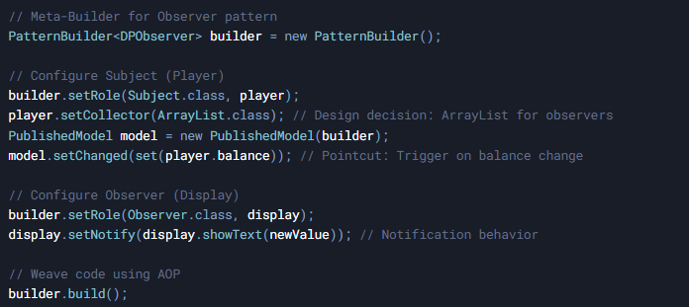

**Addressing Essential Complexity**

1. **Separation of Concerns**  
   Observer logic is modularized into reusable components, decoupling domain classes (Player, Display) from pattern implementation.
2. **Dynamic Configuration**  
   Design decisions (e.g., push vs. pull model) are configurable via the Builder, avoiding hardcoded solutions.
3. **Adaptability**  
   Changes (e.g., adding thread safety) require updates only to the Builder, not domain code.

**Impact on Essential Complexity**  
This approach reduces the *accidental complexity* (e.g., boilerplate code) while managing the *essential complexity* of cross-object collaborations. It exemplifies Brooks’ argument that complexity must be tackled through abstraction and modularization.

**Conclusion**

The Builder pattern effectively addresses essential complexity in two distinct scenarios:

1. **Pizza Ordering System**: Manages multi-attribute object construction through stepwise encapsulation.
2. **Virtual Monopoly Game**: Modularizes cross-cutting design patterns via meta-level Builders and AOP.

Both cases highlight the Builder pattern’s ability to *organize* complexity by:

* **Decoupling construction from representation**.
* **Encapsulating variability** behind well-defined interfaces.
* **Enhancing maintainability** through incremental configuration.

As Fred Brooks noted, there is “*no silver bullet*” to eliminate complexity, but patterns like the Builder provide tools to manage it systematically, fostering scalable and adaptable software systems.